Author’s Information

Ms Esther Thng
Clinical Nurse Specialist
Wound, Ostomy & Continence Nurse
BHSc (Nursing)
Adv Dip in Nursing (Orthopaedic)

MSc (Wound Healing & Tissue Viability) – currently pursuing

Institution of practice:
Sozo Wound & Stoma Care
Novena Medical Centre
10 Sinaran Drive
#09-01
Singapore 307506

INTRODUCTION

A 30-year-old male patient was referred to our clinic for wound management on 9 February 2021 following saucerization of scalp abscess done on 19 January 2021. There was slow progression in wound healing despite wound dressing done twice a week in the surgeon’s clinic since operation. The patient was also receiving chemotherapy treatment for recurrent cancer of the colon. Chemotherapy was discontinued due to the development of the scalp abscess and subsequent surgery. There was therefore an urgent need for wound healing to be expedited in order to resume his chemotherapy treatment.
On examination, the wound was located at the occiput and measuring 1.6cm by 5.7cm with a depth of 1.4cm. Wound bed was clean with some fibrinous and granulation tissues seen. Exudate level was low with hemoserous fluid noted upon removal of previous dressing. Wound edge was irregular.
The considerations for SNAP therapy system were the size of the wound, the exudate level and the lifestyle of the patient. The size of the wound was able to fit into the standard dressing kit which is 10cm by 10 cm. Exudate level was low and therefore would be able to contain within the cartridge which has a capacity of 60mls. The patient is young and lead an active lifestyle and hence preferred a device that is portable and discreet. As it is mechanically powered, the patient did not have to worry about being in a situation where the battery runs out and needs to be charged. In addition, there are evidence that negative pressure wound therapy (NPWT) can accelerate wound healing (Armstrong et al. 2012), which was crucial in this case as the patient needed to continue his chemotherapy treatment.

METHODS
SNAP therapy was initiated on 9 February 2021 and was planned for 2 weeks. The wound was cleansed thoroughly with an antiseptic solution, a hydrocolloid layer was placed around the wound edge for periwound protection, followed by a strip paste to help secure the seal. The foam was cut to size and place in the wound bed and covered by the hydrocolloid dressing kit. The tubing was cut to a length that was comfortable for the patient and not restricting movement. It was then connected to the cartridge and the device was activated by pressing the activation key. Pressure was set at 125mmHg and there was no leakage detected. The device was secured on the patient’s arm with the strap provided and hidden from view by his clothes.

RESULTS
SNAP therapy system was initiated on 9 February 2021 with the last application on 18 February 2021. Dressing changes were carried out twice a week and there was a total of four SNAP therapy system applications. During this period, the wound bed remained clean, there were increased in granulation tissues and reduction in depth noted. Contraction of wound edges was also evident resulting in a closer approximation of the wound edges. There was a significant reduction in wound size (60%) during the last application on 18/2/21. The wound bed was prepared sufficiently for secondary closure on 22 February 2021. During the follow-up visit on 1 March 2021, the sutures remained intact and no gapping of the wound was noted. Removal of sutures was done on 8 March 2021 and the patient was discharged from follow-up.

At baseline (9/2/21)
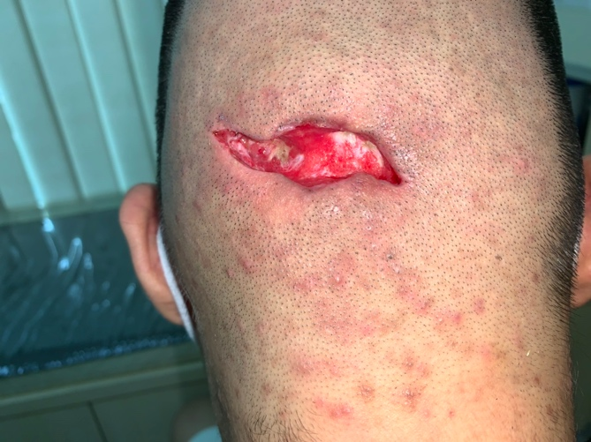
With SNAP therapy system applied
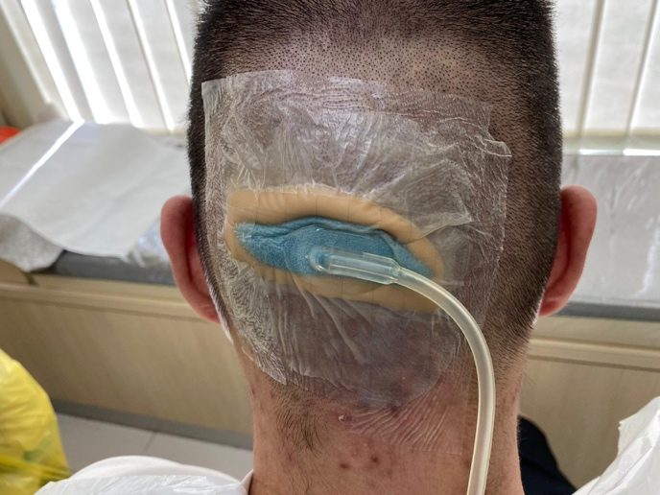

One week after commencement (15/2/21)

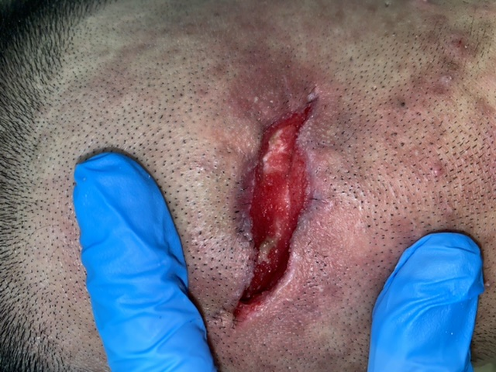

End of therapy (18/2/21)

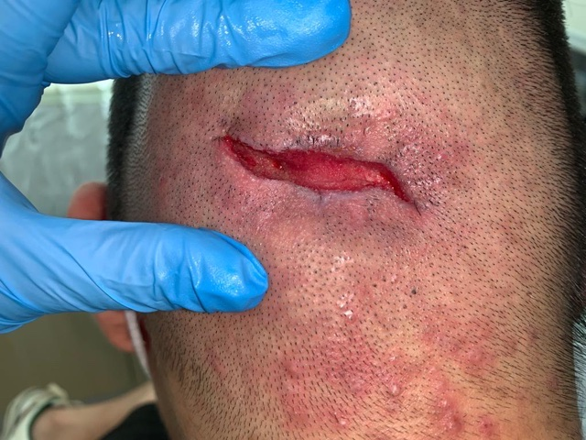

Follow-up (7 days post secondary suture – 1/3/21)

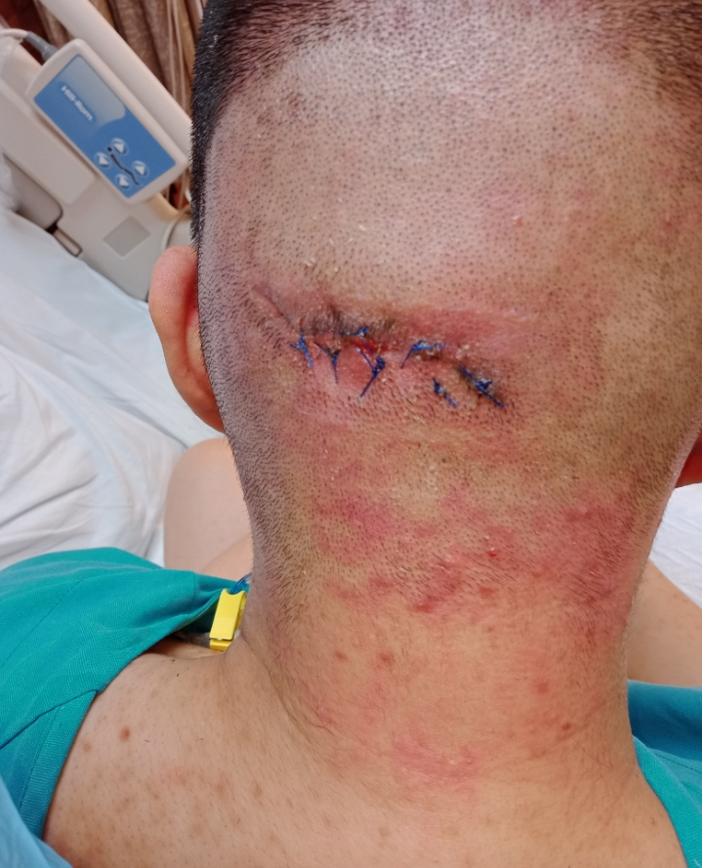

Follow-up (14 days post secondary suture – 8/3/21)

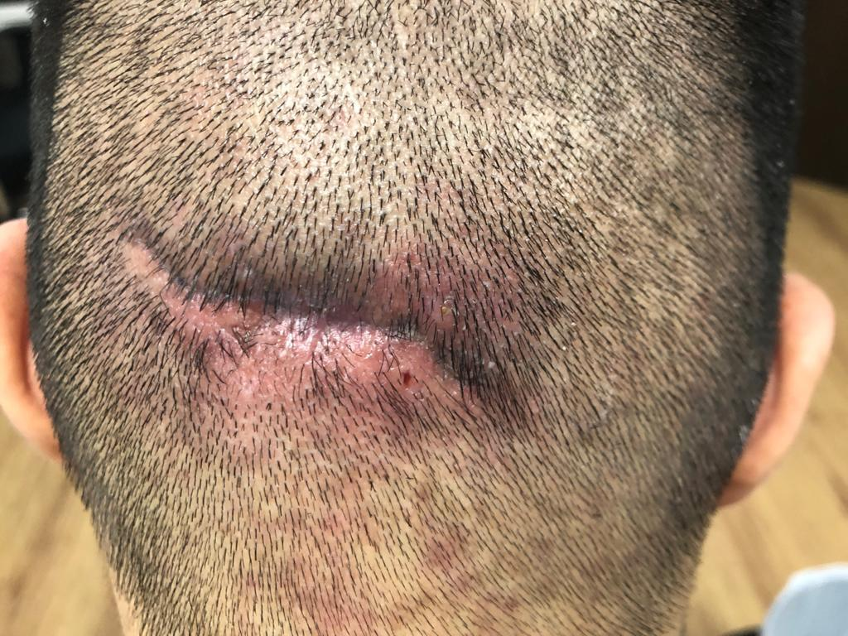

DISCUSSION

In recent years, disposable NPWT has gained popularity in the management of wounds as it is portable, discreet and may help to improve the patient’s quality of life compared to traditional NPWT (Armstrong et al. 2012). In addition to being fully disposable, the SNAP therapy system is also mechanically powered, eliminating the need to charge the device compared to those electrically powered ones.
In a case series from Singapore reported by Wee et al. (2019), the authors concluded that the SNAP therapy system is an effective tool in treating small sized wounds and may serve as an adjunctive treatment in wound management. Patients in this case series also reported high satisfaction with the device in terms of convenience and less impact on daily activities. Similarly, the results of this case study reported favorable outcomes when SNAP therapy system was applied on a small sized wound. It was noted that prior to SNAP therapy system application, the patient had standard of care comprising of wound cleansing and advanced wound products for three weeks with slow healing outcome. Since commencement of the SNAP therapy system, the wound bed was kept clean with an increased in granulation tissue, reduction in wound size and significant wound contraction, rendering it possible for secondary suture to be done in less than two weeks. More importantly, the patient’s daily activities and quality of life were not compromised, thereby improving compliance and overall outcomes.

CONCLUSION
This case study was a 30-year-old male who developed an abscess at the occiput and had saucerization done. Post-operatively, his wound was treated with standard care and after three weeks, there was slow progression towards healing. SNAP therapy system was applied and in less than two weeks, the wound bed was well prepared and ready for closure through secondary suture. Time was an important consideration in this case as the patient has recurrent cancer of the colon and chemotherapy was put on hold when he developed the abscess. The rapid closure of the wound, which was facilitated by the SNAP therapy system, would enable the patient to continue the chemotherapy treatment. In addition, the mechanically powered SNAP therapy system which is portable and light weight appears to have less impact on the patient’s quality of life as compared to the electronically powered devices (Armstrong et al. 2012).

DECLARATION OF INTEREST
The author has no conflict of interest to report.

REFERNCES
Armstrong, D. G. et al. 2012. Comparative effectiveness of mechanically and electrically powered negative pressure wound therapy devices: a multicenter randomized controlled trial. Wound Repair And Regeneration 20(3), pp. 332-341.

Wee, I. J. et al. 2019. The smart negative pressure (SNaP) wound care system: A case series from Singapore. International Wound Journal 16(4), pp. 891-896.

